Online Judge

SECURED ONLINE CODING PLATFORM (DJANGO-BASED WEBSITE)

Low Level Design Document

Muskan (2020CSB1100)

Tummala Sanjana Reddy (2020CSB1137)

Kushal Agrawal (2020CSB1096)

Ruchika Sharma (2020CSB1119)

Isha Goyal (2020CSB1089)

Introduction

The document consists of internal logic and communication between each and every component that is explained in System Level Design document.

Modules:

Authentication: This is used to authenticate users to access the website.Every user first needs to register on the system (successful after the email verification) and then login using the correct credentials. For security reasons password will not be directly stored in raw form but instead will be stored in the hashed format. Option to change password will also be given in case one forget the password, in this case the user will be verified through email.After login the options for change password, logout and update profile will be present. Appropriate error messages are shown accordingly.

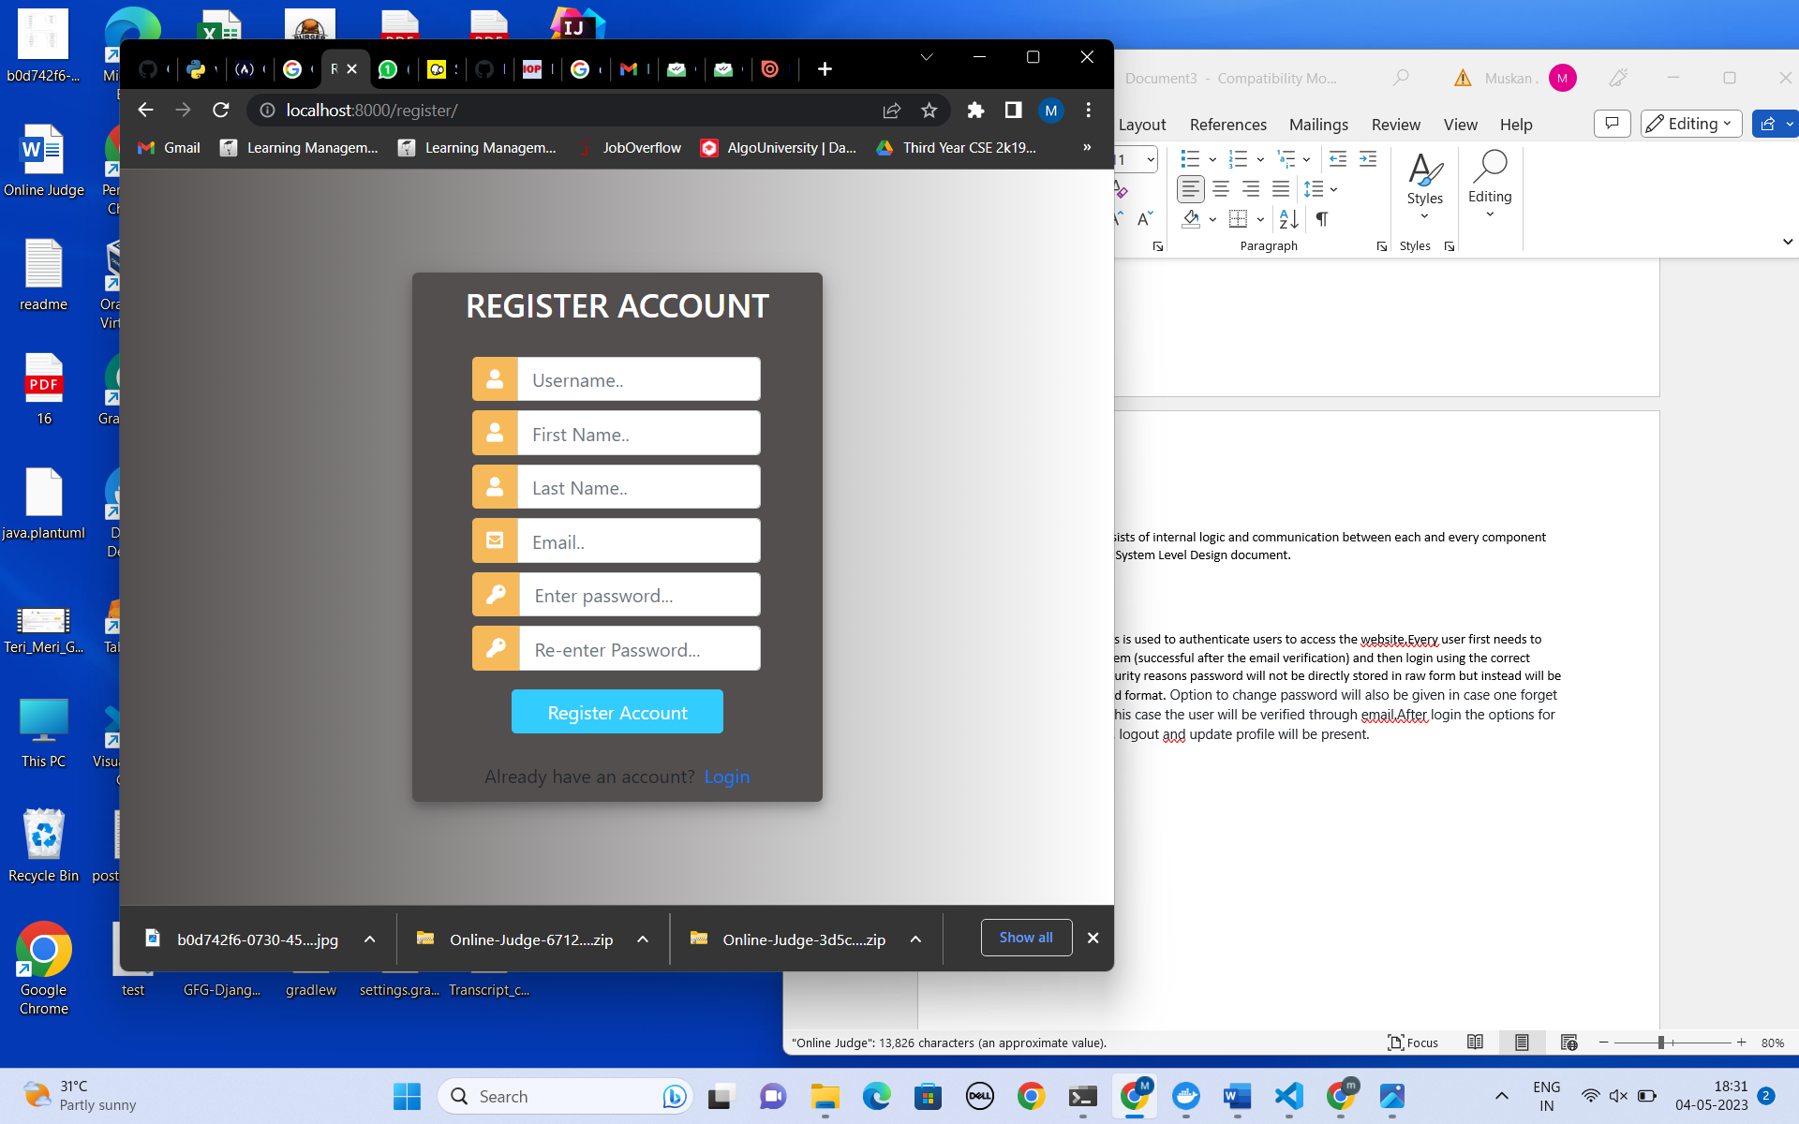 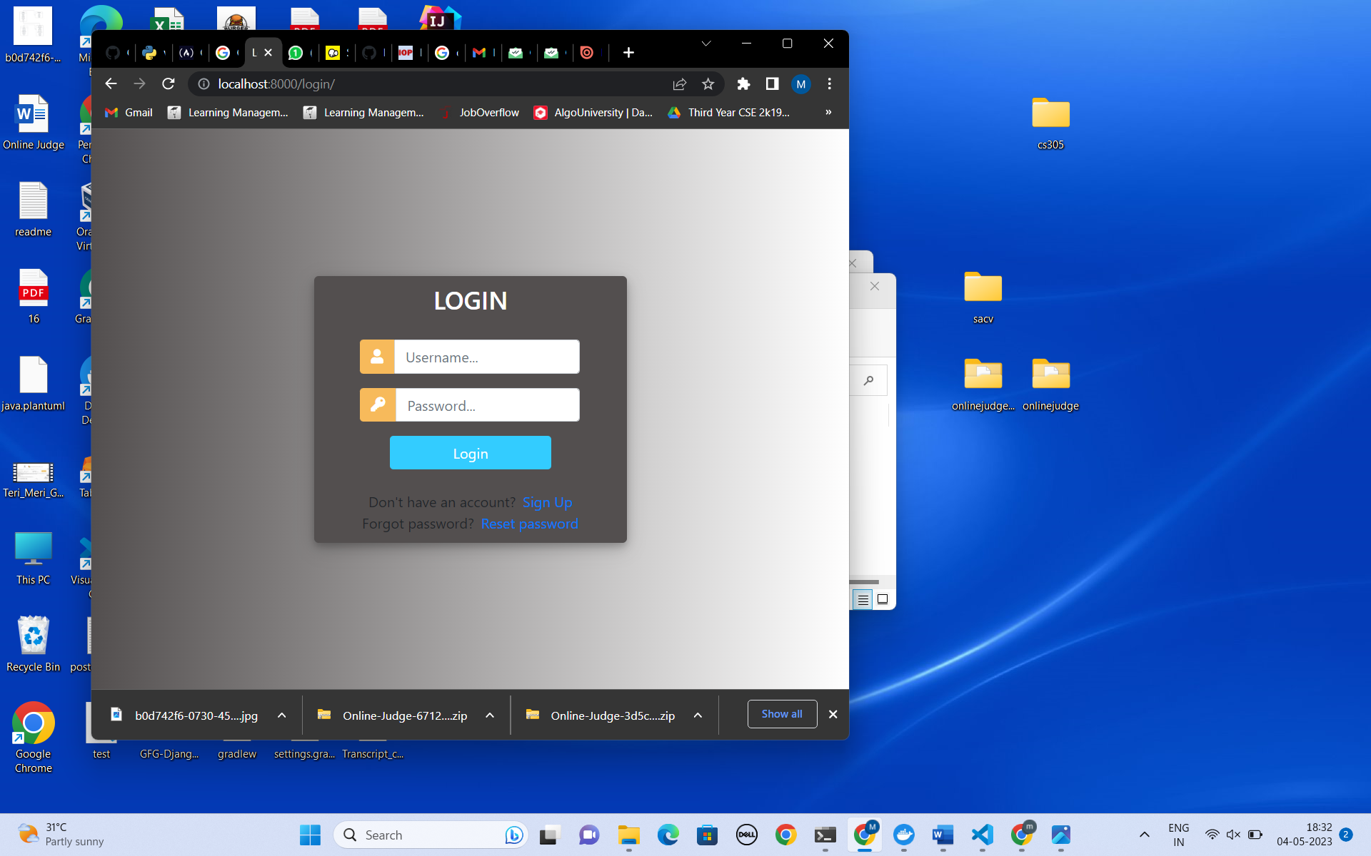 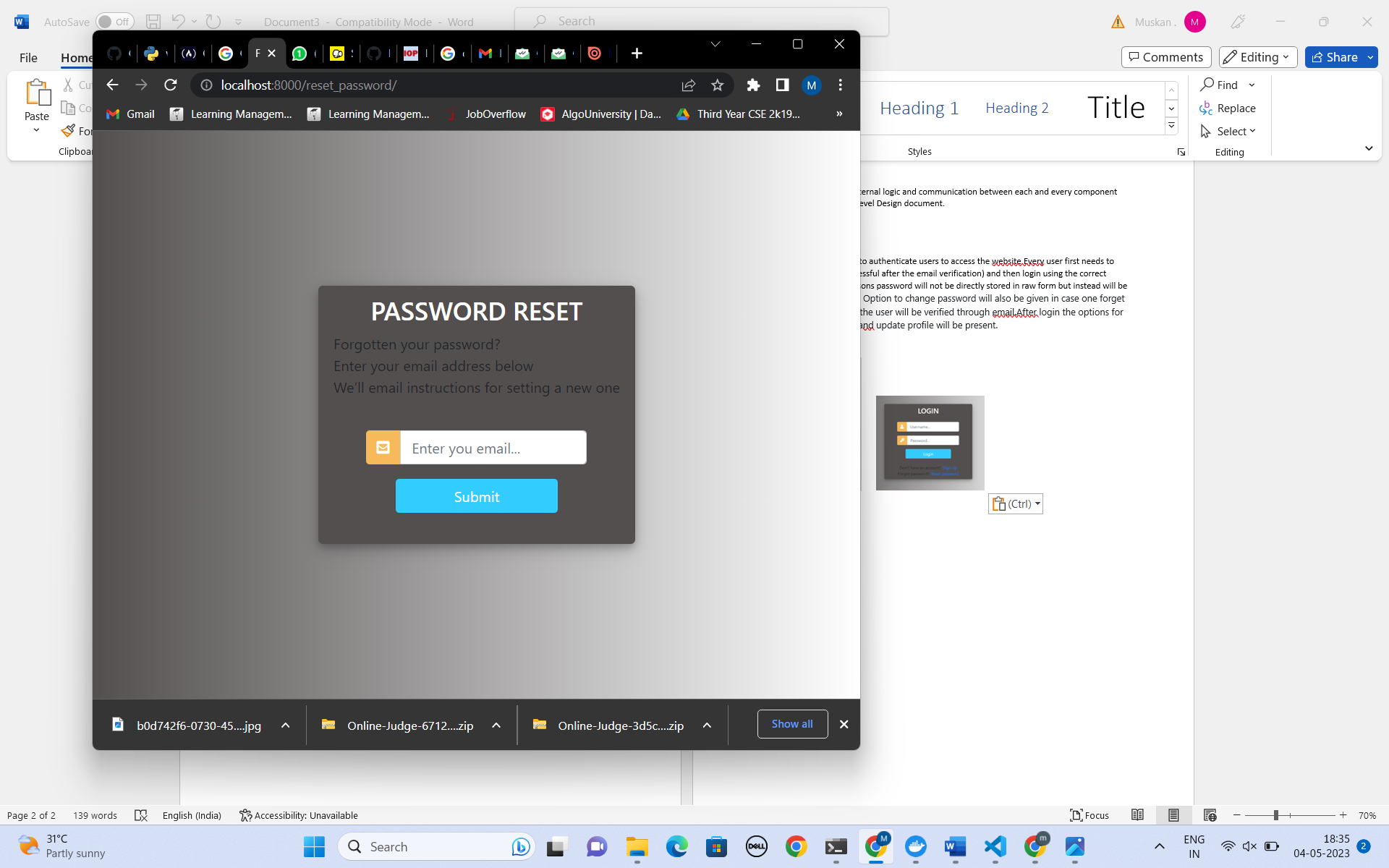

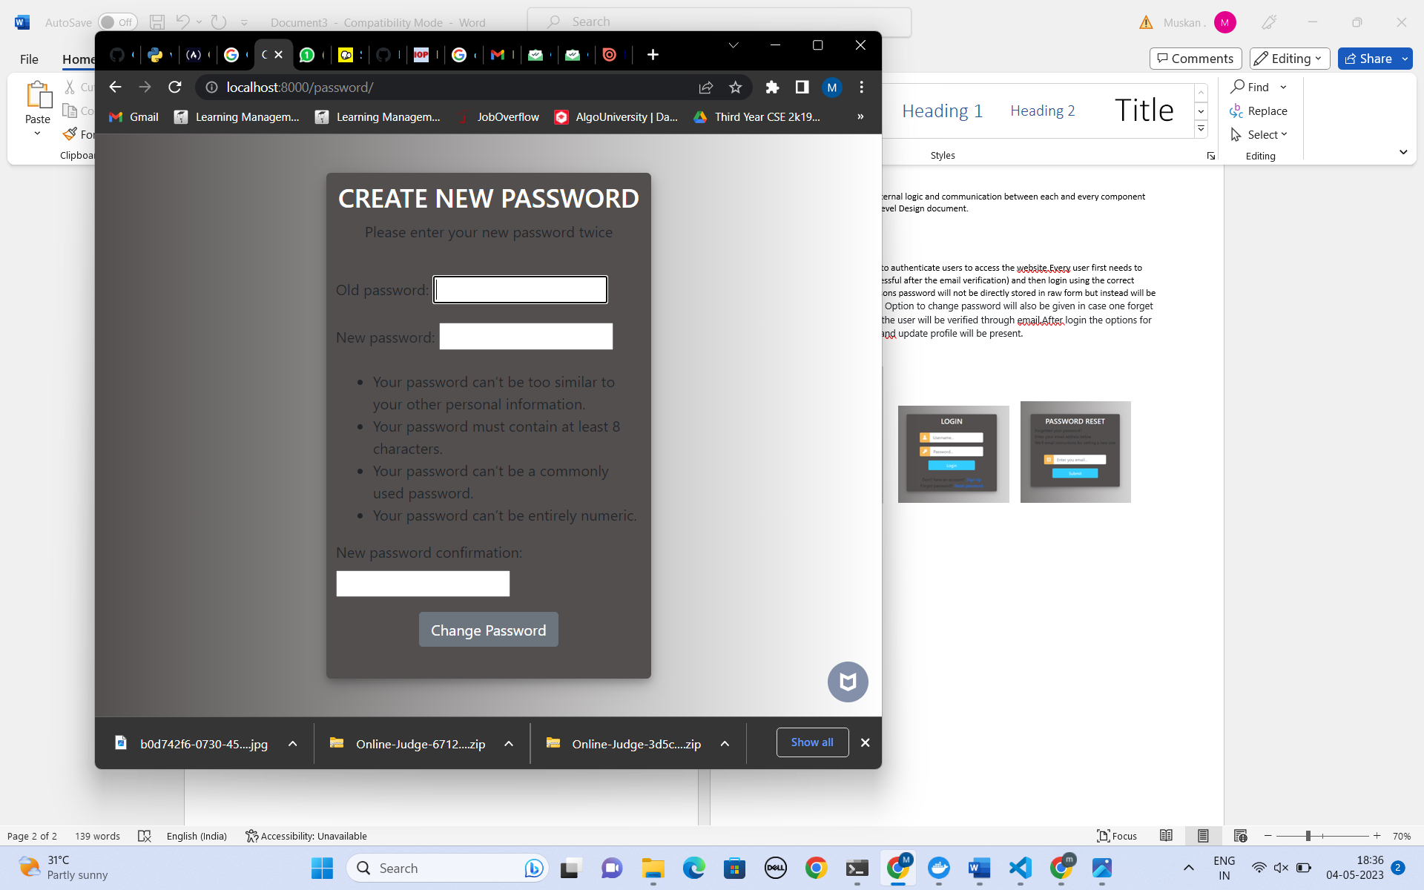 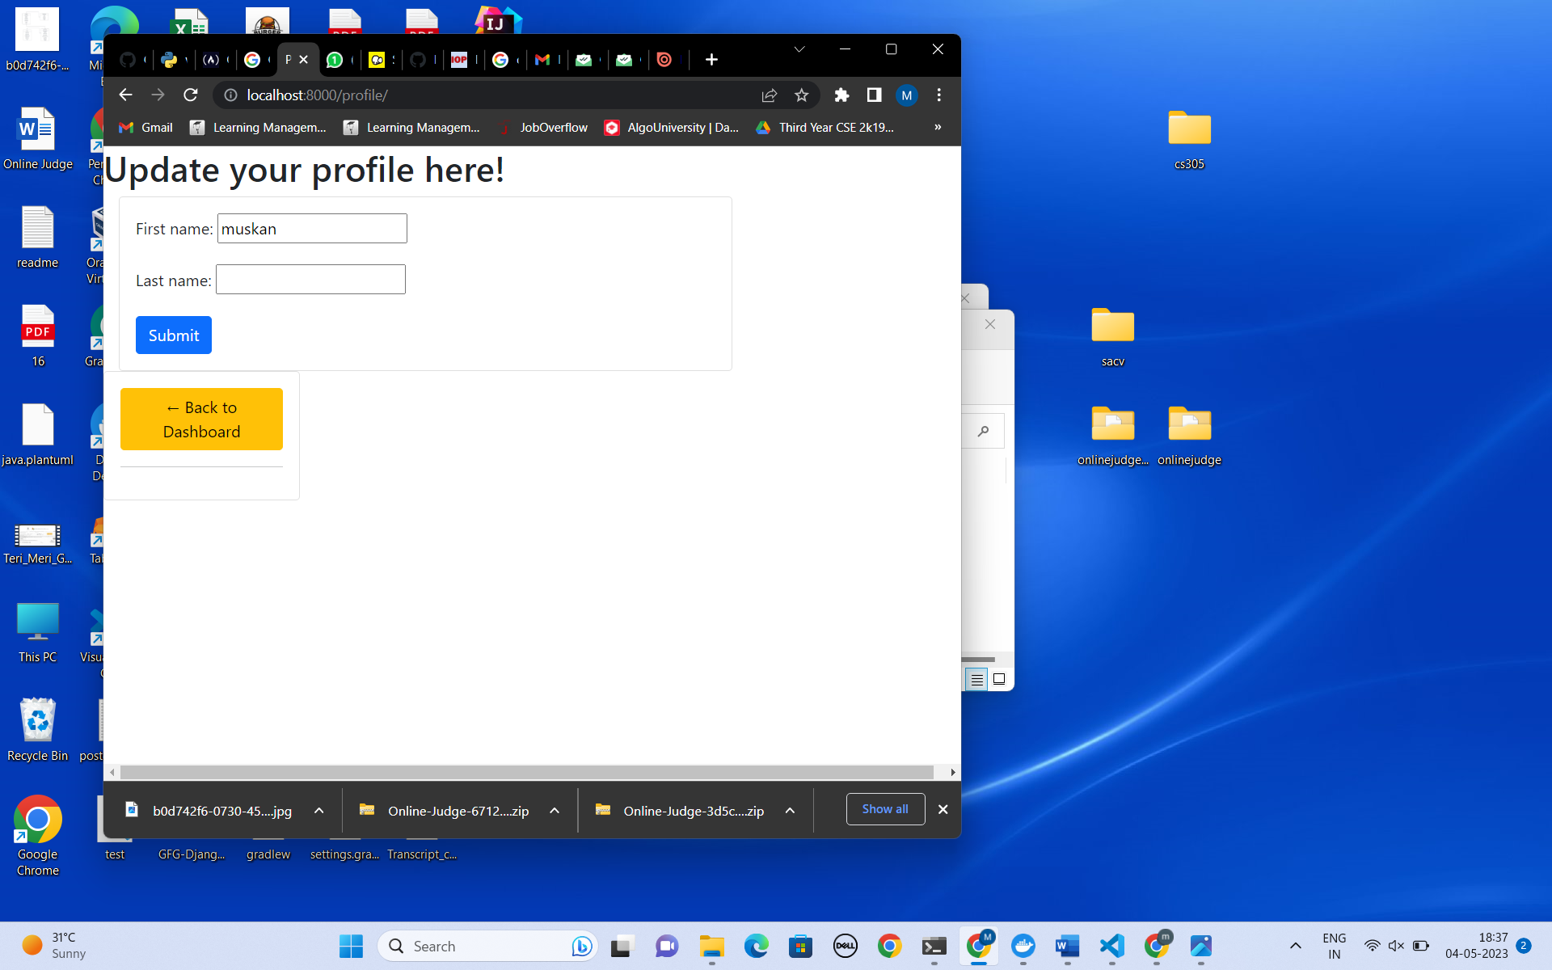

Authorization: Authentication and authorization might sound similar, but they are distinct security processes in the world of identity and access management (IAM). Authentication confirms that users are who they say they are. Authorization gives those users permission to access a resource. Here in our case the participant is not allowed to view setters’ pages and admin pages and at the same time, the setter is not allowed to access admin’s functionalities.

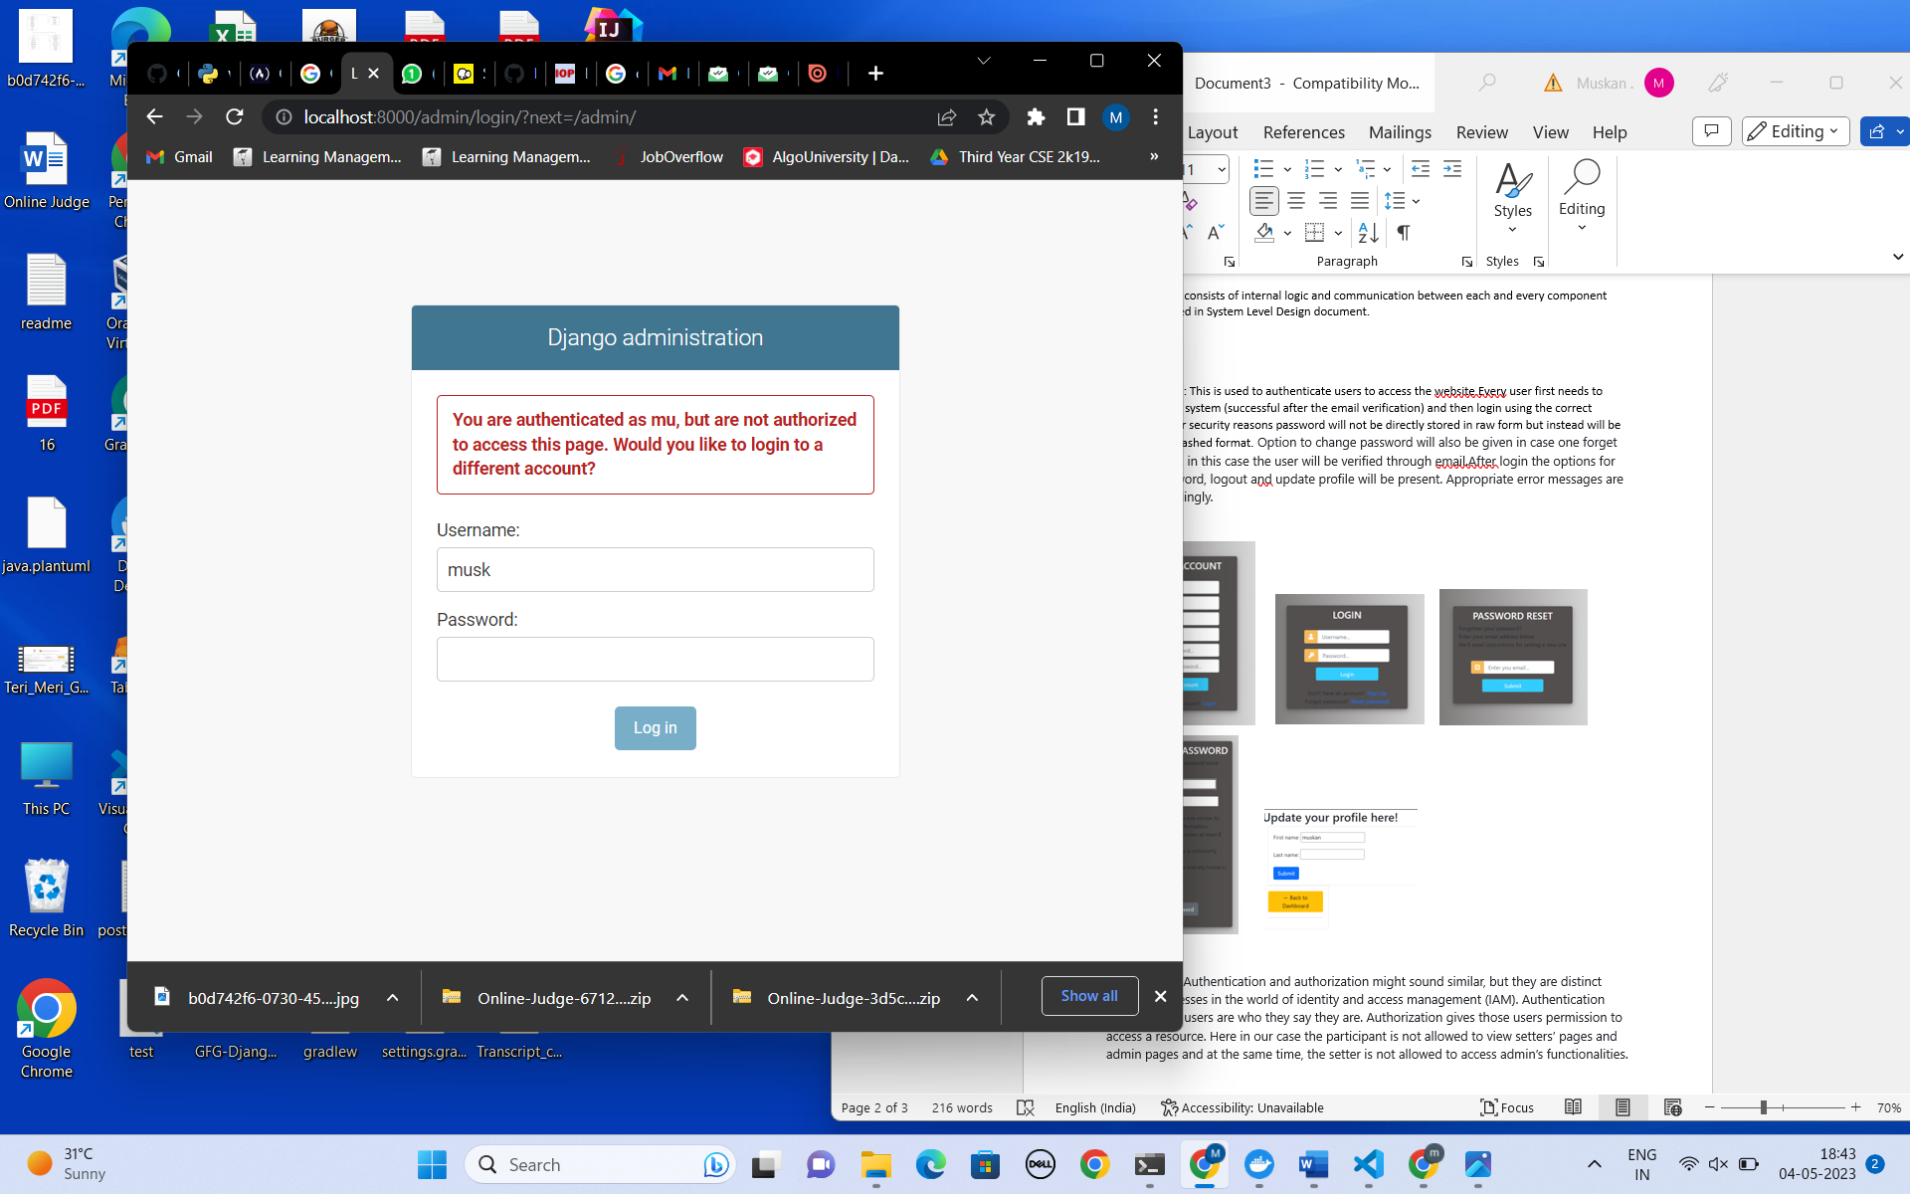 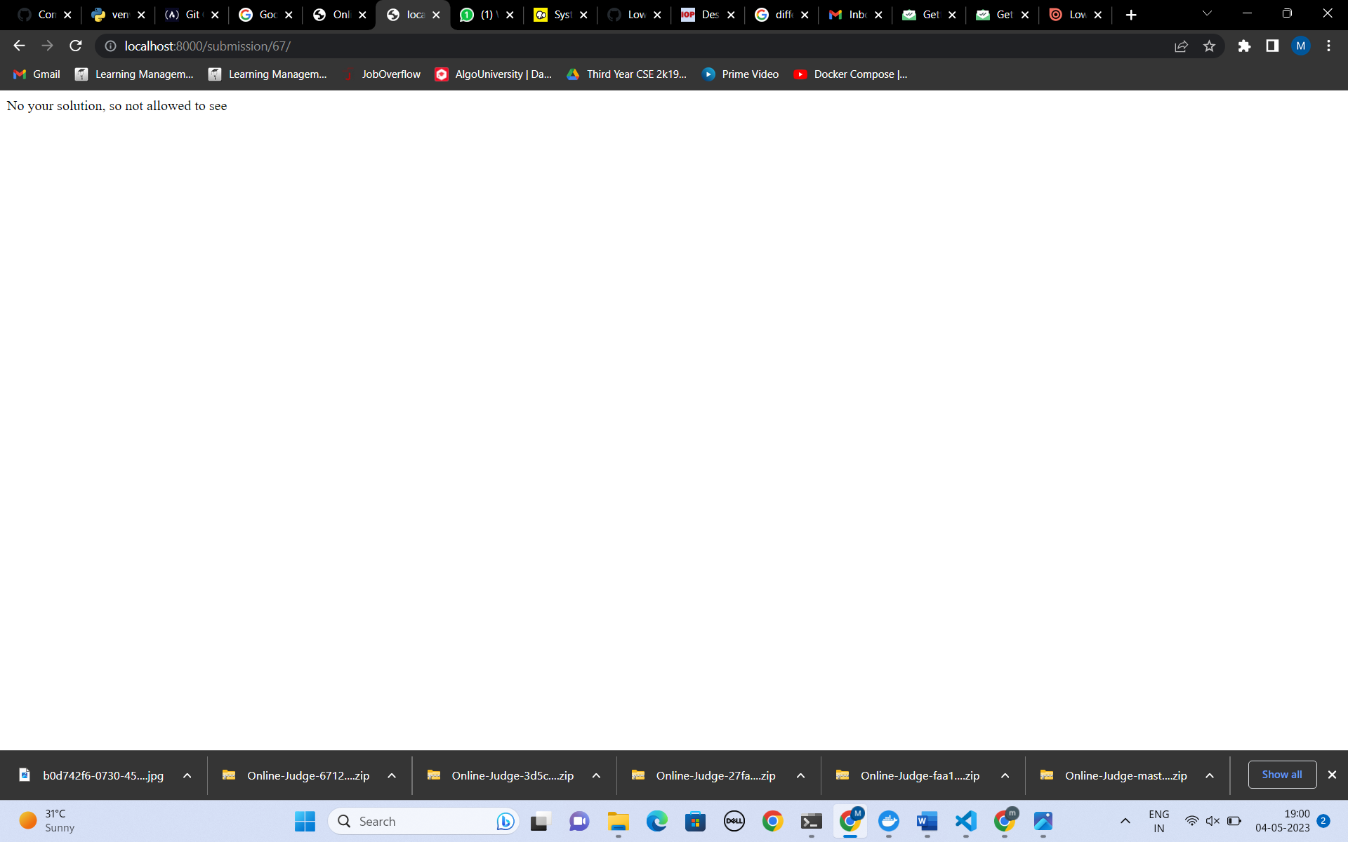

Participant Mode: Maintaining database facilitates history of submissions and leaderboard to user. Verdict will be shown to user in accordance with test cases and constraints.

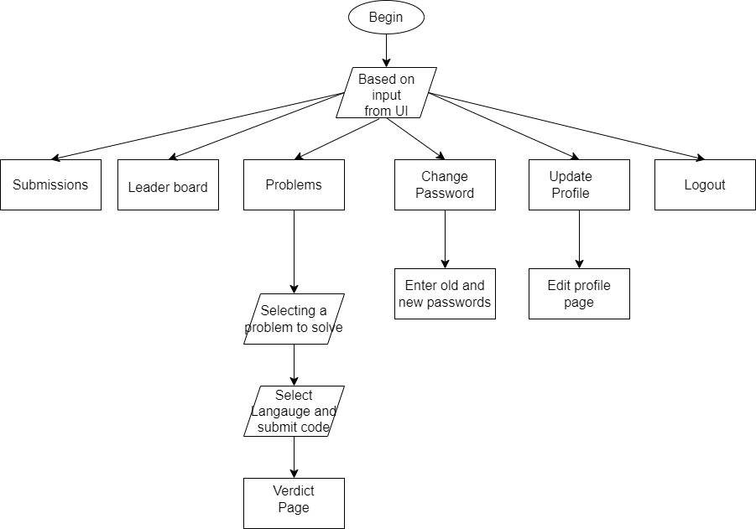

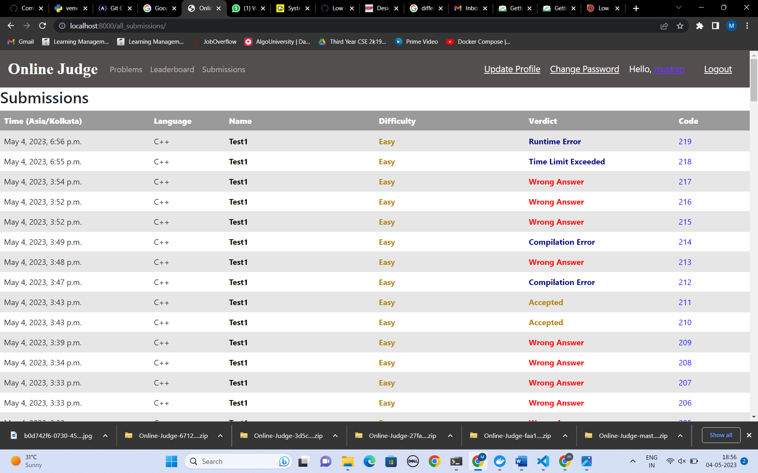

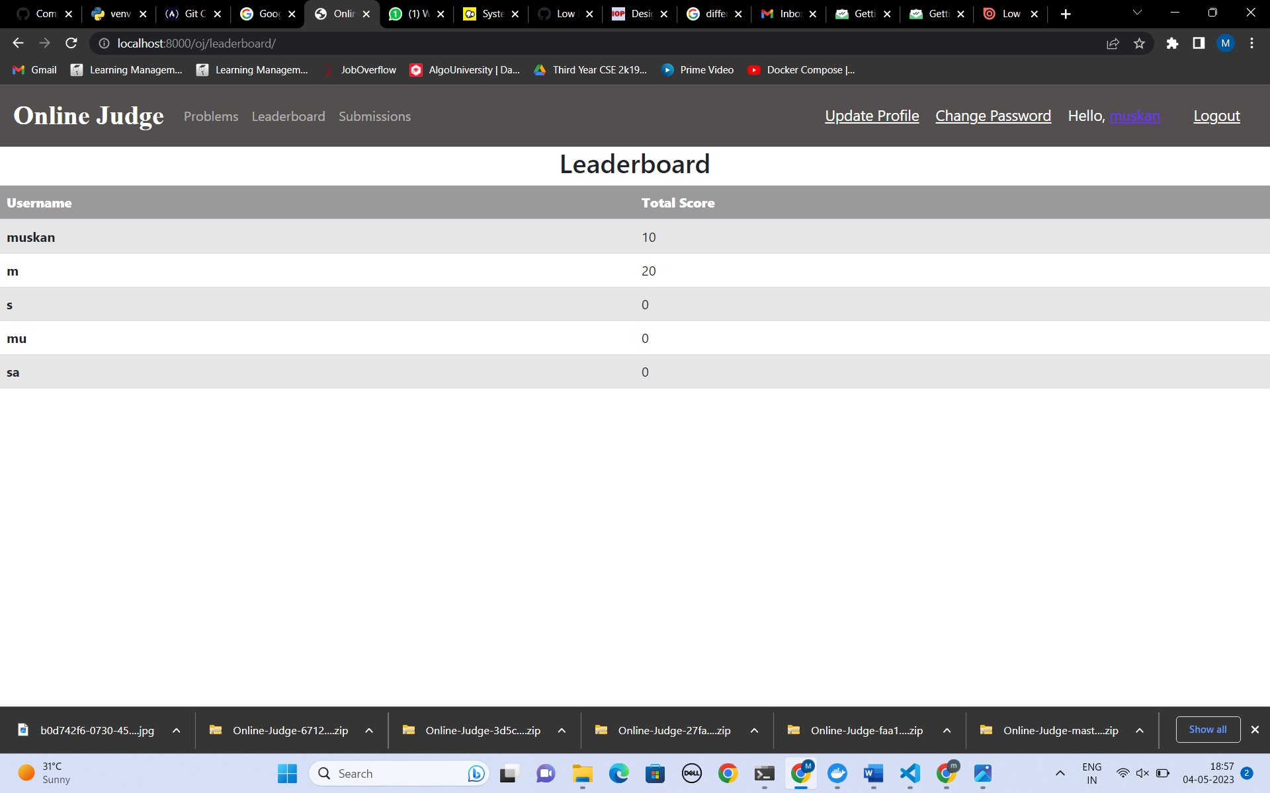

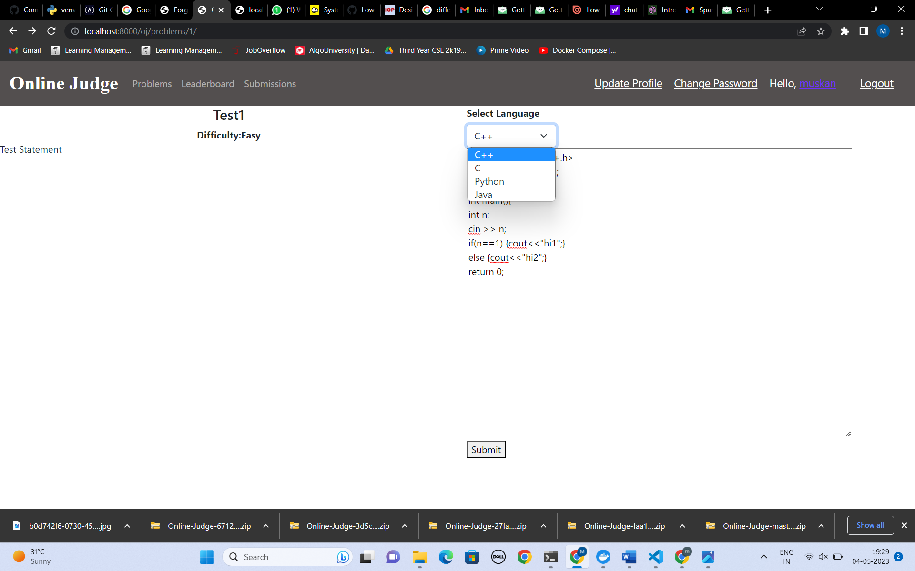 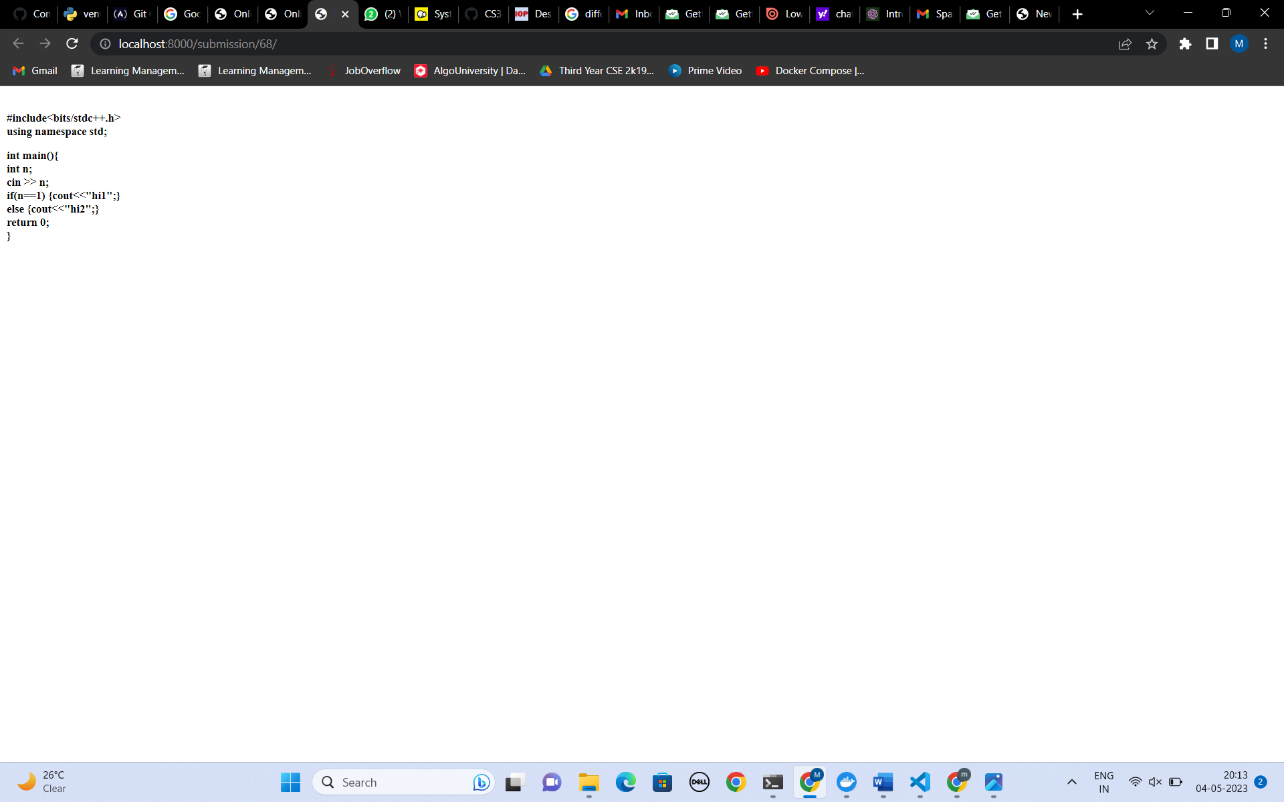

Setter mode: Maintaining author of problem allows them to later modify the problem and any authorized person can add new problems and test cases also using dynamic forms.

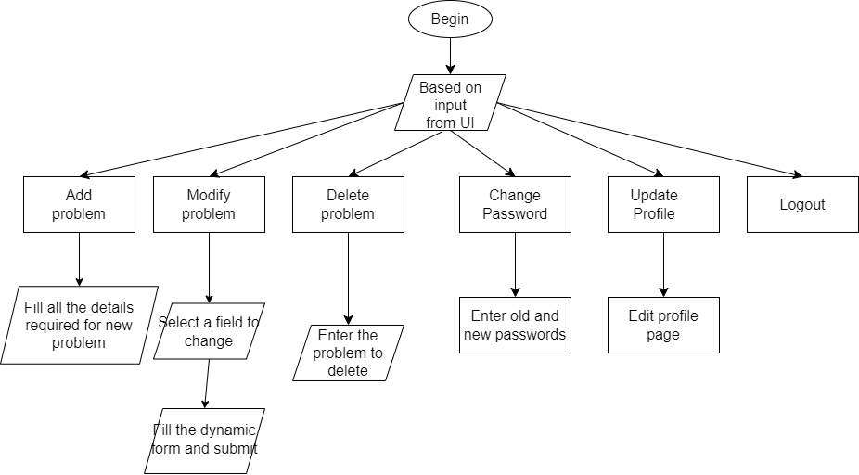

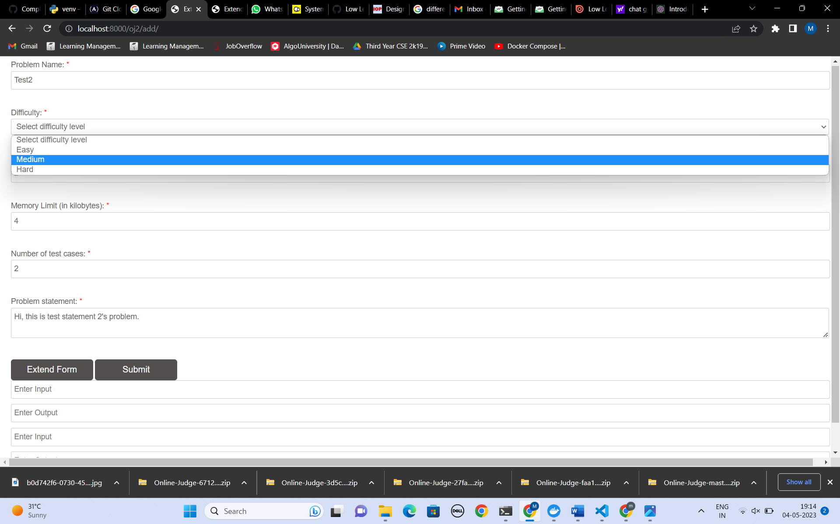 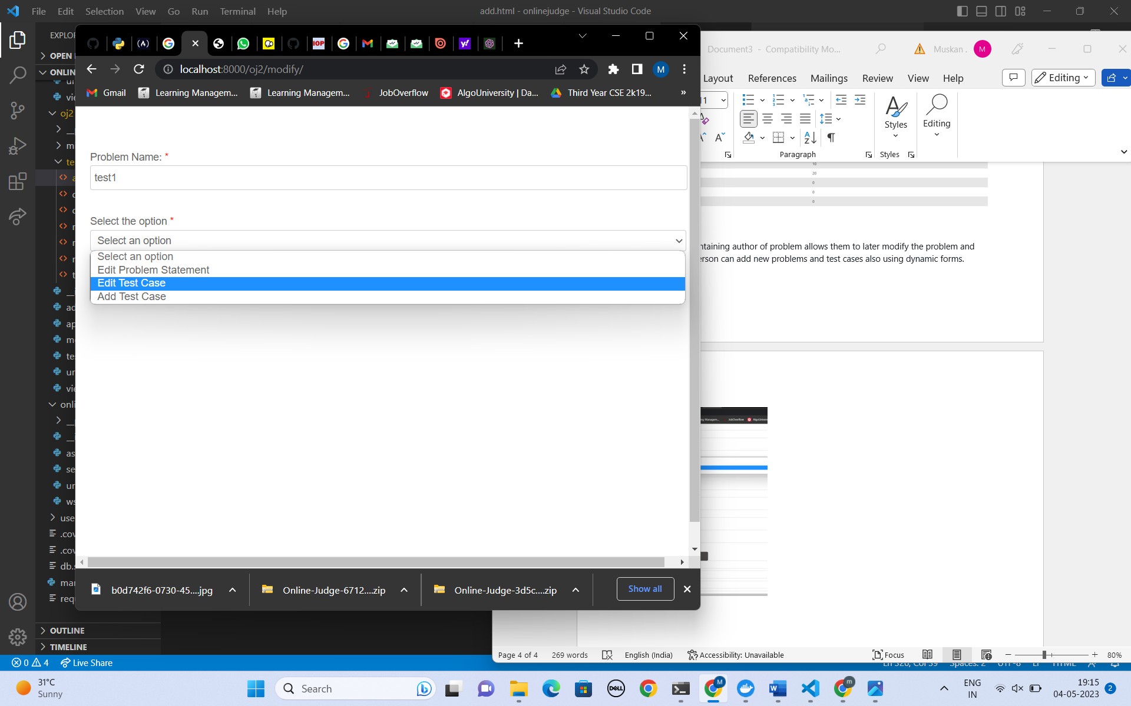

Super User Mode: Its main function is to change role by making users as staff members so that they are now authorized as setters of problems also.

Code Execution: Code is executed for multiple test cases in a separate isolated environments(containers) for handling malicious code.

